MICCAI2021

High frequency words for segmentation task:

transformer, for segmentation, and 1 paper for multimodal brain tumor segmentation

contrastive learning,

uncertainty-aware(guided),

meta learning,

multi-task learnining,

dual-branch strategy, (dual-network branch, local-global dual perception idea)

data augmentation for semi-supervised segmentation

knowledge distillation

coarse to fine segmentation( two stages solution)

federate learning

domain adaptation, for cross-modality segmentation

features(find clues from feature space)

add the number of networks, e.g. one encoders and two or more decoders.

multi-modality segmentation: co-training, GAN,

federate learning from Chen zhen. PFA and DET diversity

Domain adaptation

**Paper1:** Atrial General: Domain Generalization for Left Atrial Segmentation of Multi-center LGE MRIs

The authors make performance comparison of 4 architectures in terms of 3 Domain Generalization schemes: Histogram matching (HM)[1], Mutual information based disentangled (MID) representation[2], Random style transfer (RST)[3].

HM is performed on the images from the target domain to match its intensity histogram onto that of the source domains. The model and training process do not change. In MID-Net, domain-invariant features are extracted by mutual information based disentanglement in the latent space, while in RST-Net available domains are augmented via pseudo-novel domains.

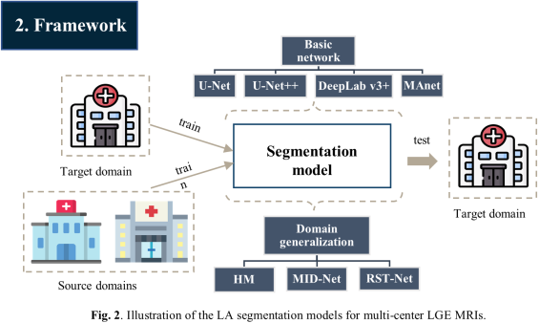

refs:

1. Histogram matching augmentation for domain adaptation with application to multi-centre, multi-vendor and multi-disease cardiac image segmentation
2. Mutual information-based disentangled neural networks for classifying unseen categories in different domains: application to fetal ultrasound imaging
3. Random style transfer based domain generalization networks integrating shape and spatial information

**Paper2:** Adapting Oﬀ-the-Shelf Source Segmenter for Target Medical Image Segmentation

The mean and variance in BN(low order batch statistics) across domains are different. Forcing the same mean and variance across domains can lead to a loss of expressiveness. However, the scaling and shifting parameters(high order batch statistics) are shareable across domains.

The authors separately train the source(supervised) and target domain(minEntropy). The accumulated mean and variance in BN from source domain are initialized to BN in target domain, then an exponential decay scheme is used to update the mean and variance of BN in target domain. The methods encourages scaling and shifting parameters consistency(L1-norm) between the two domains.

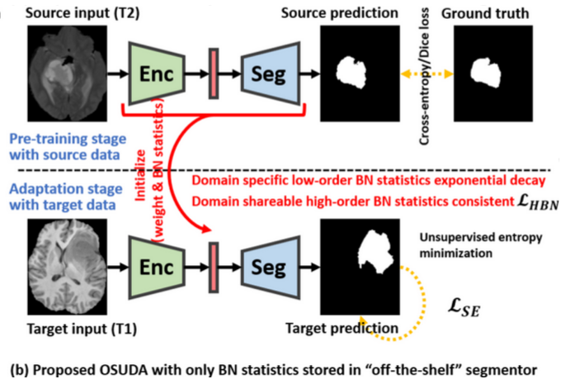

**Paper3:** Domain Generalization for Mammography Detection via Multi-style and Multi-view Contrastive Learning

Multi-style and multi-view contrastive learning ------->self-supervised learning

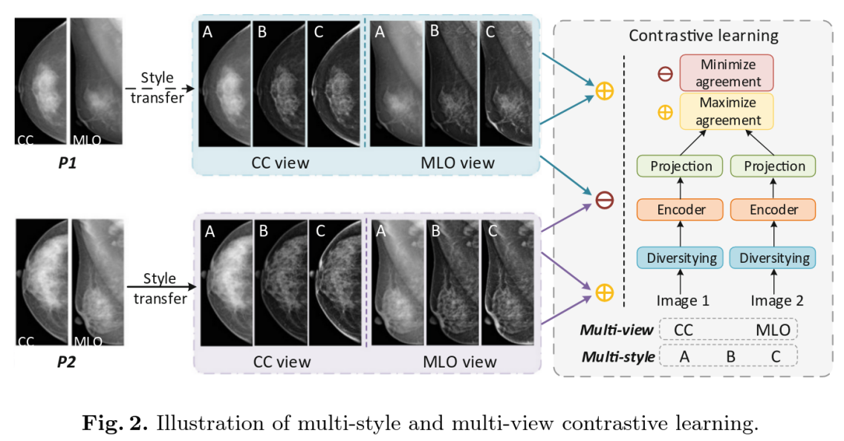

**Paper4:** Semantic Consistent Unsupervised Domain Adaptation for Cross-Modality Medical Image Segmentation

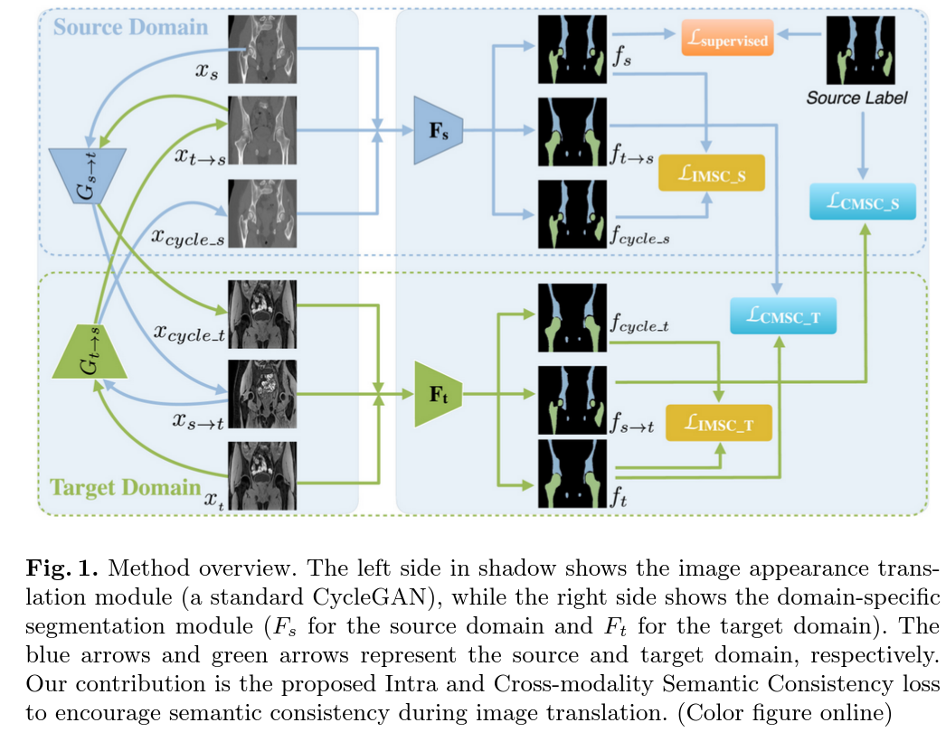

Semi-segmentation

**Paper1:** Dual-Consistency Semi-supervised Learning with Uncertainty Quantification for COVID-19 Lesion Segmentation from CT Images

1. image-level consistency and feature-level consistency
2. The conﬁdence uncertainty and the consensus uncertainty are quantiﬁed by mean and standard deviation of the multi-decoders’ predictions.
3. uncertainty-guidance means filtering out uncertain voxels based on the thresholds

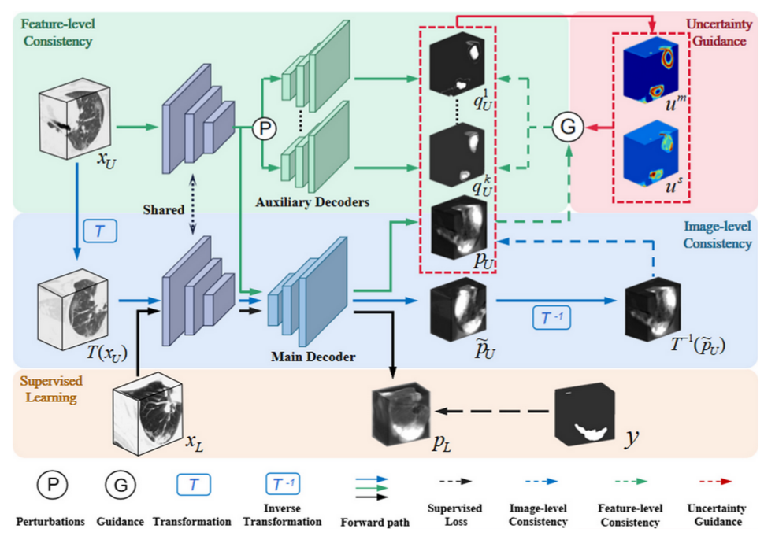

**Paper2:** Semi-supervised Left Atrium Segmentation with Mutual Consistency Training

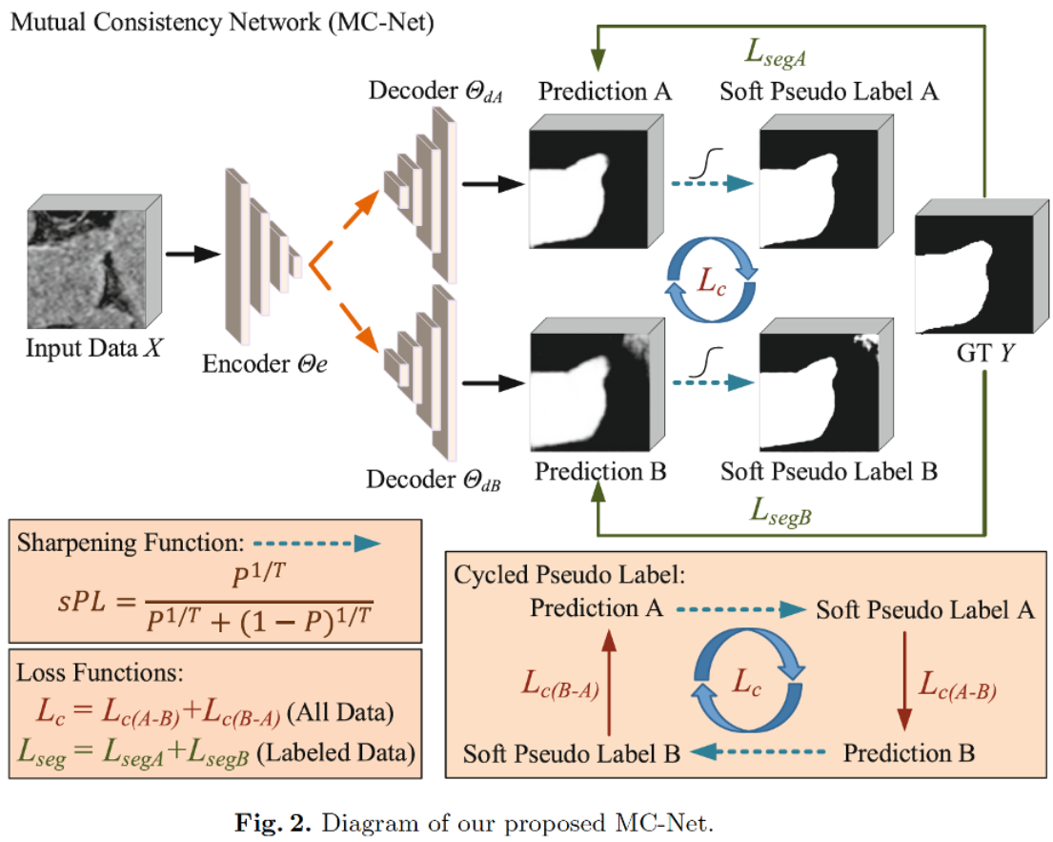

**Paper3:** Duo-SegNet: Adversarial Dual-Views for Semi-supervised Medical Image Segmentation

$φ()$ likes a classification, determining the input is from ground-truth or prediction.

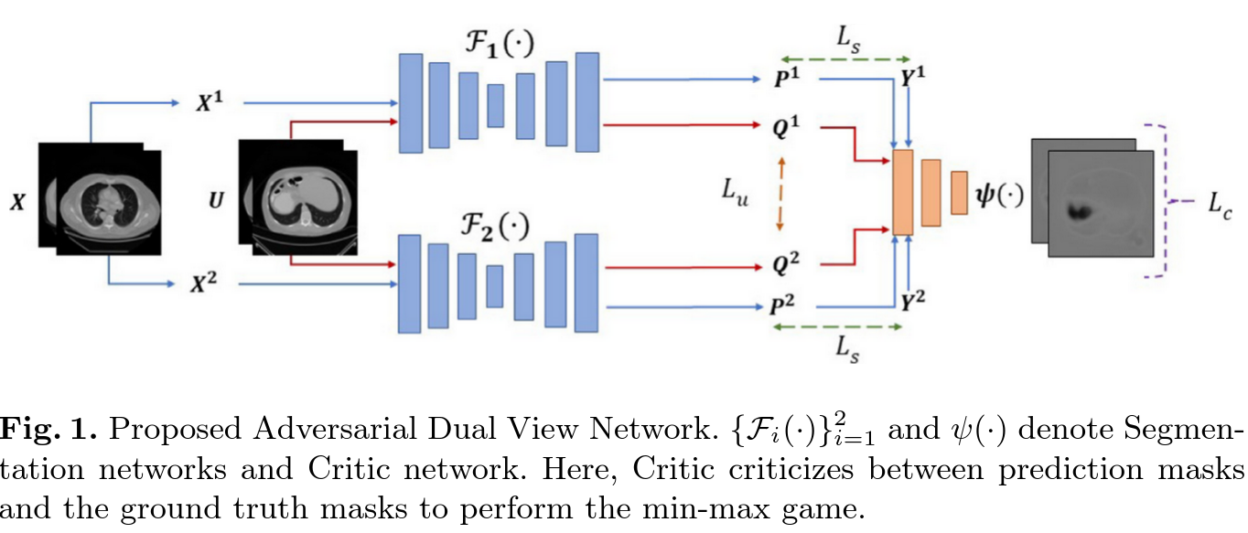

**Paper4:** Semi-Supervised **Unpaired Multi-Modal** Learning for Label-Eﬃcient Medical Image Segmentation

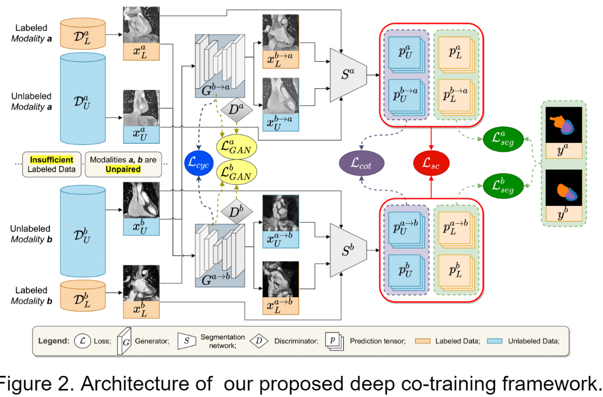

**Paper5:** Tripled-Uncertainty Guided Mean Teacher Model for Semi-supervised Medical Image Segmentation

Inspired by the semi-supervised learning and multi-task learning

data-level consistency, model-level consistency(temporal ensembling, Mean Teacher)--------->auxiliary networks(task-level)

1. supervised loss for 3 tasks on student model
2. inter-model consistency loss between student and teacher
3. inter-task consistency loss on student model

uncertainty map: different from the average of results from MC, estimate a weight for each sample, and then get a weighted map.

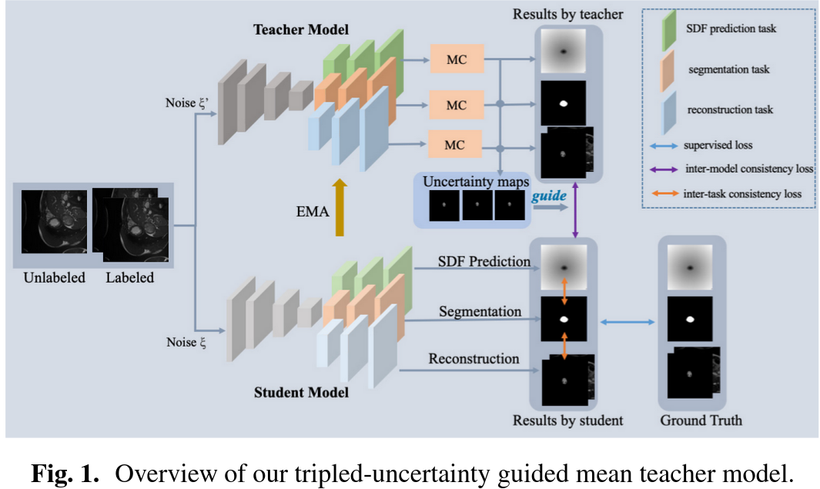

**Paper6:** Positional Contrastive Learning for Volumetric Medical Image Segmentation

Contrastive learning is used to pretrain the encoder which is initialized to the fine-tunning stage.

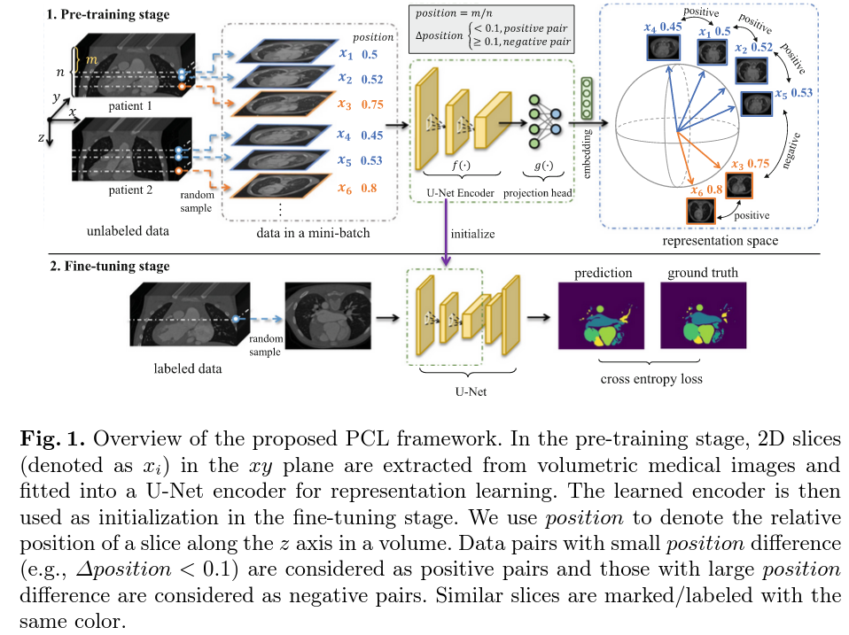

**Paper7:** Segmentation of Left Atrial MR Images via Self-supervised Semi-supervised Meta-learning

**Paper8:** Semi-supervised Contrastive Learning for Label-Eﬃcient Medical Image Segmentation

**Paper9:** Source-Free Domain Adaptive Fundus Image Segmentation with Denoised Pseudo-Labeling

............................to further have a look----

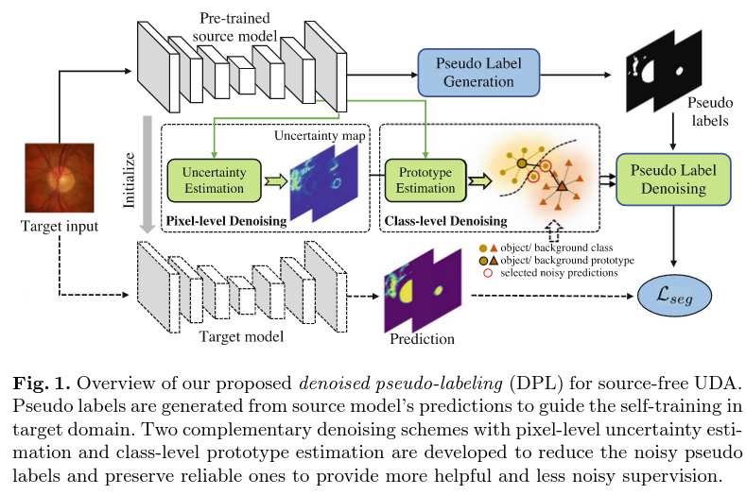

**Paper10:** Confidence-Aware Cascaded Network for Fetal Brain Segmentation on MR Images

1. coarse-to-fine style
2. In coarse stage, the target localization region is segmented, and slices with confidence as well. In fine stage, confidence guided for low confidence slices strategy is proposed to perform segmentation task.

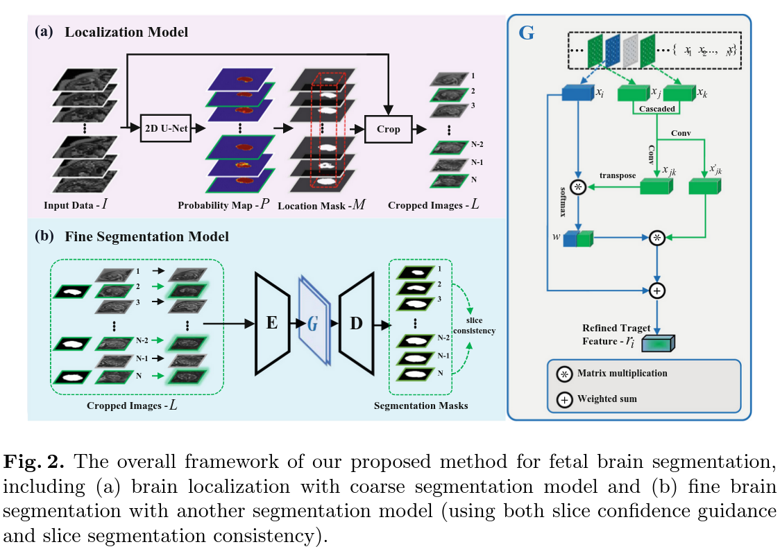

**Paper11:** Distilling Eﬀective Supervision for Robust Medical Image Segmentation with Noisy Labels

-->pixel-level and image level

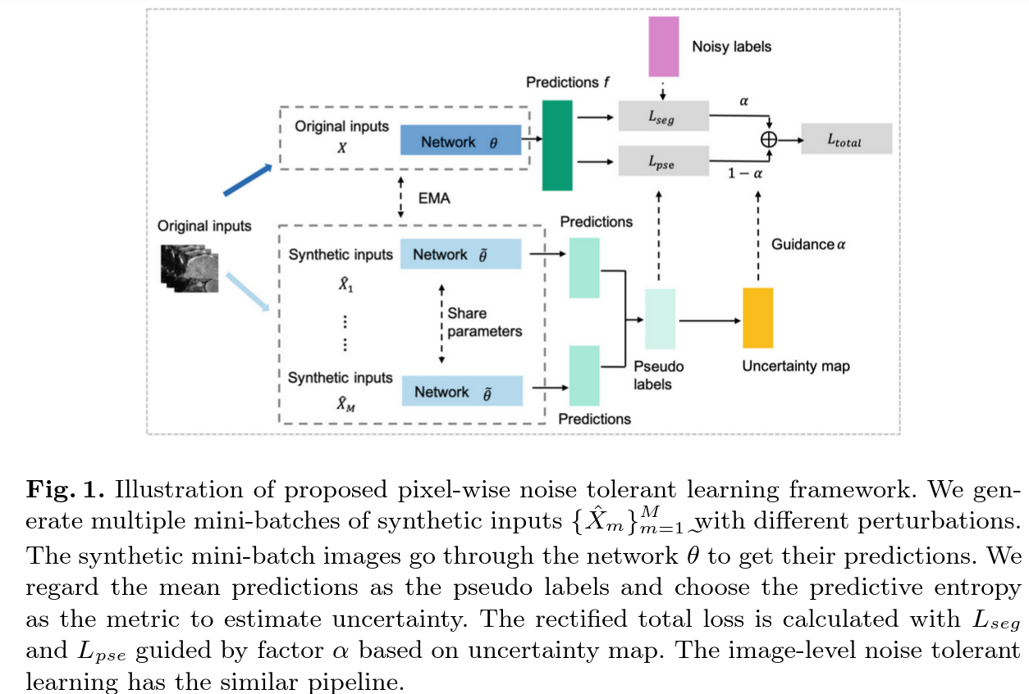

**Paper12:** ACN: Adversarial Co-training Network for Brain Tumor Segmentation with Missing Modalities

----------to further have a look

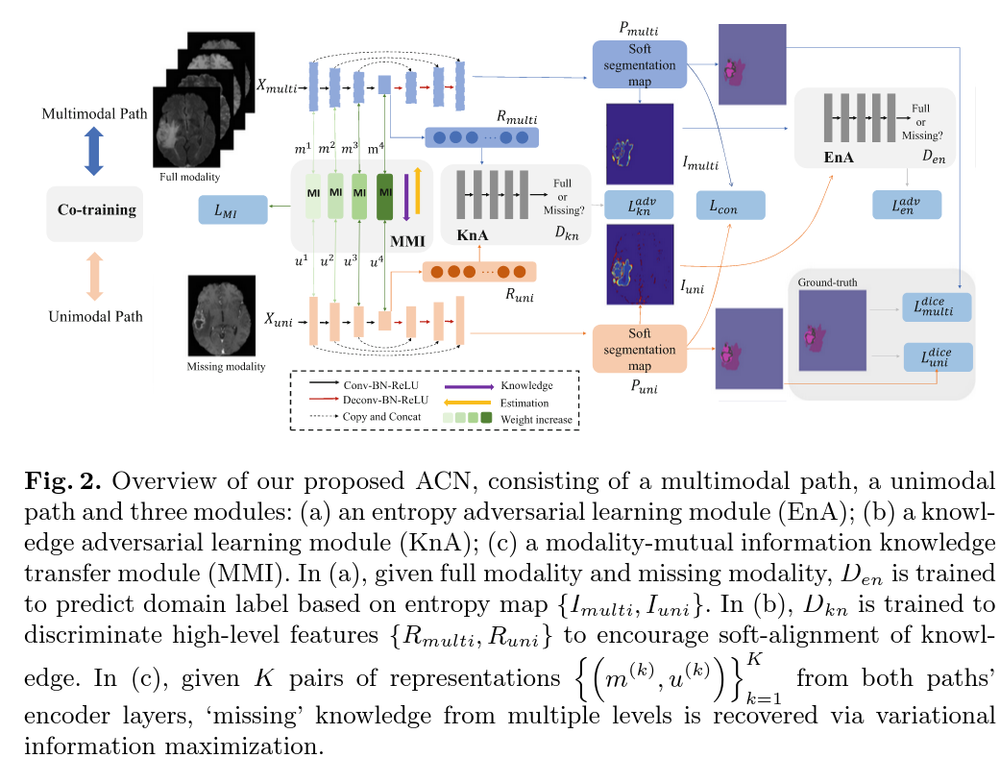

**Paper13:** A Spatial Guided Self-supervised Clustering Network for Medical Image Segmentation

-------to have a look

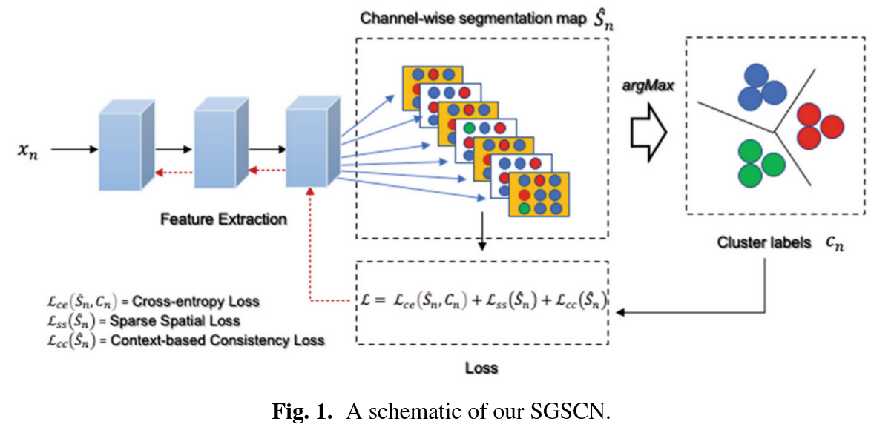

**Paper14:** Coarse-To-Fine Segmentation of Organs at Risk in Nasopharyngeal Carcinoma Radiotherapy

it is an end-to-end two-stage method.

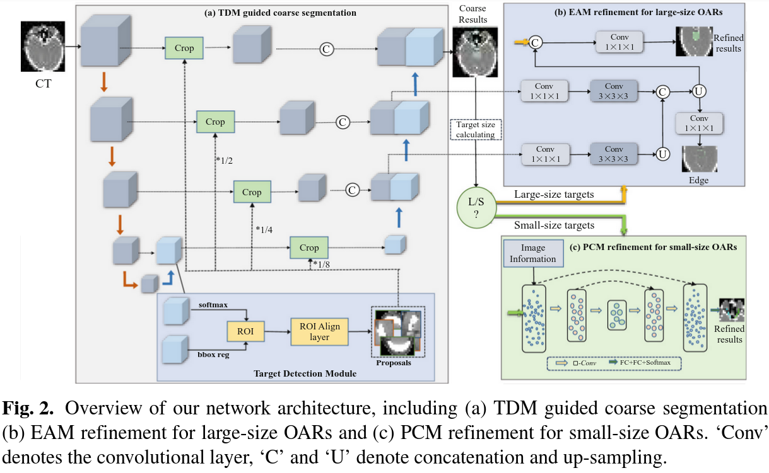

**Paper15**: CarveMix: A Simple Data Augmentation Method for Brain Lesion Segmentation

2 labeled image----->1 labeled image

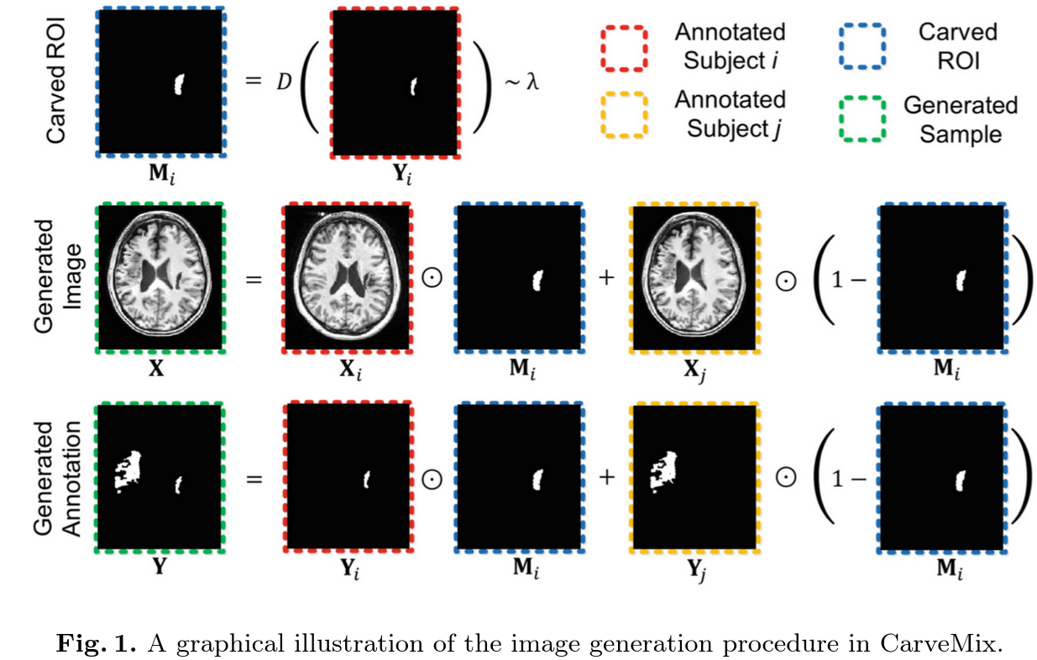

**Paper16:** Modality-Aware Mutual Learning for Multi-modal Medical Image Segmentation

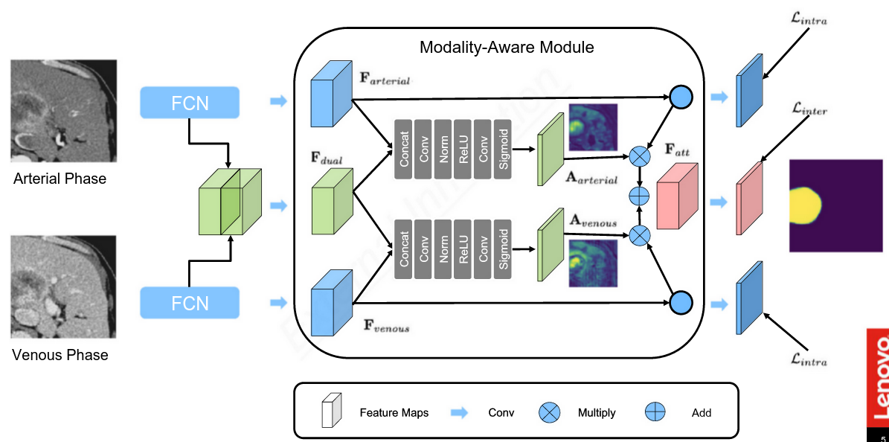

**Paper17:** MT-UDA: Towards Unsupervised Cross-modality Medical Image Segmentation with Limited Source Labels

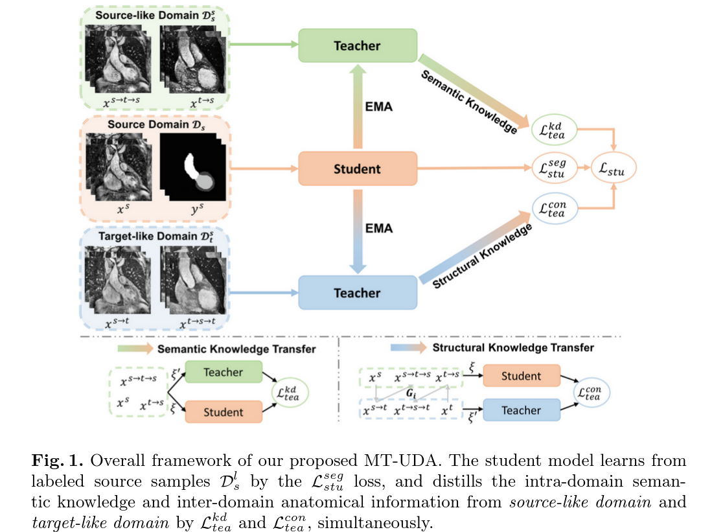

**Paper 18:** TumorCP: A Simple but Eﬀective Object-Level Data Augmentation for Tumor Segmentation

**Paper19:** TransBTS: Multimodal Brain Tumor Segmentation Using Transformer

Federated learning

**Paper1:** Personalized Retrogress-Resilient Framework for Real-World Medical Federated Learning

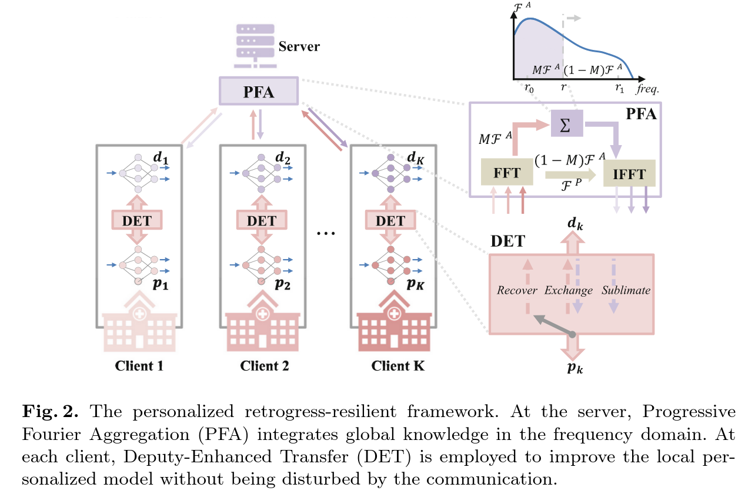

**Paper2:** Federated Semi-supervised Medical Image Classification via Inter-client Relation Matching

Federated semi-supervised learning(FSSL)

